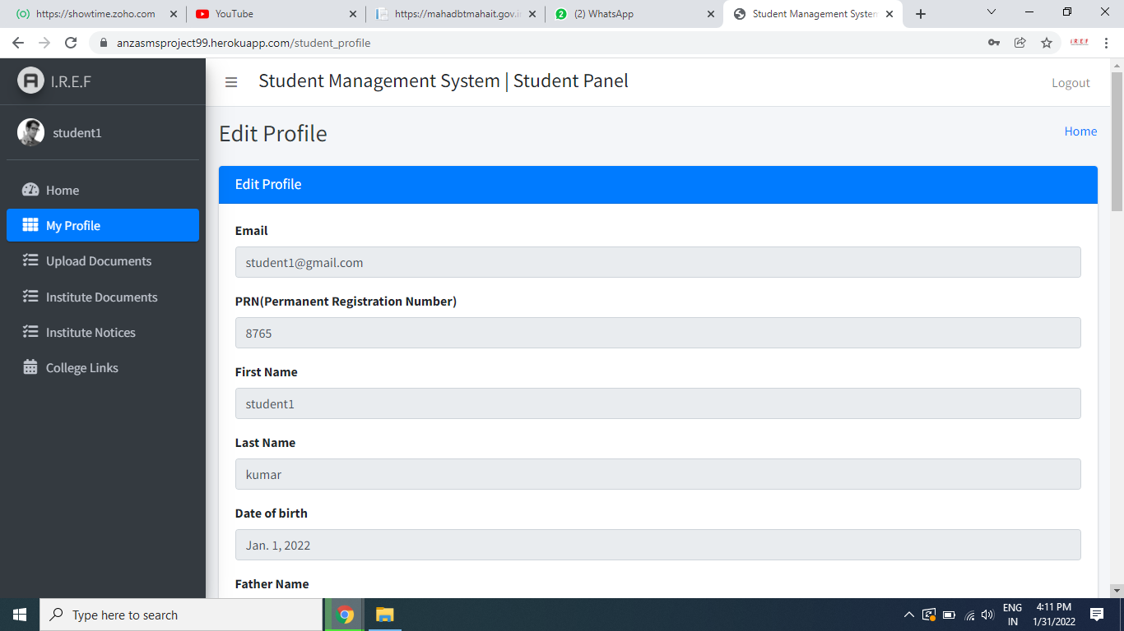

1.In student portal some tab has got freeze we are unable to do changes.

**(Apart from email students can now able to edit all fields as per your request in updated student profile page) – You are viewing old student profile page)**

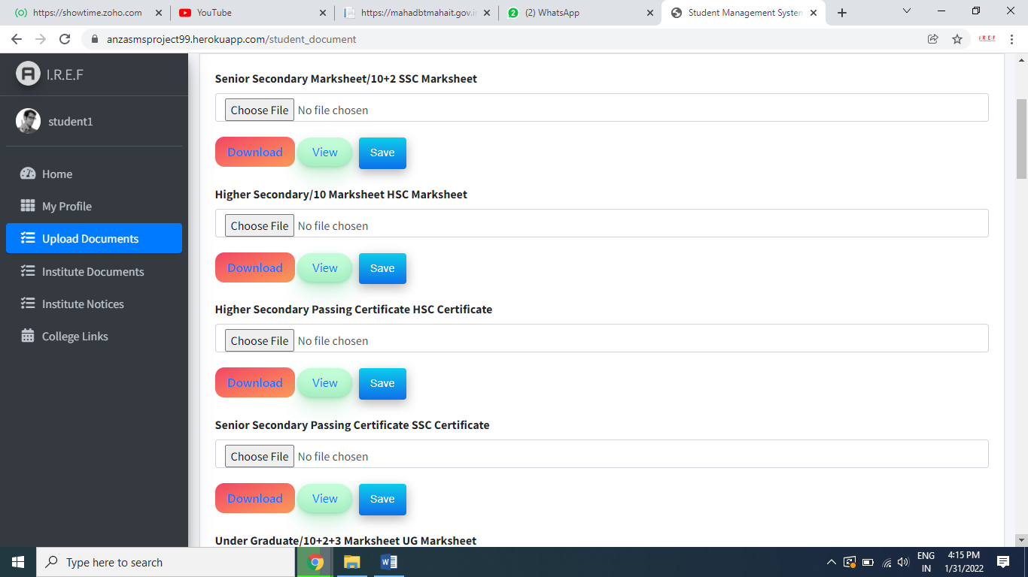

3.put sequence wise rows - **(Done)**

1.SSC marksheet

2.SSC certificate

3.HSC Marksheet

4.HSC Certificate

5.Diploma Marksheet

6.Diploma Certificate

7.UnderGraduate marksheet

8.undergraduate certificate.

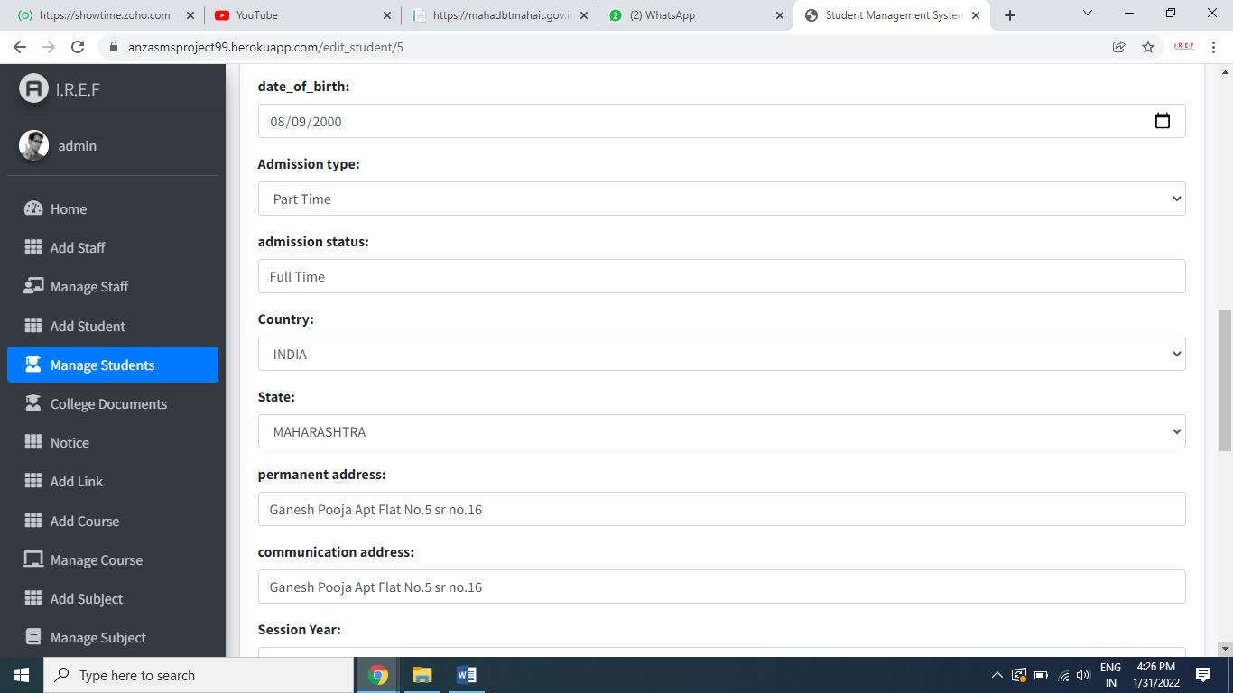

6.Remove Admission Status

1- Provisional admission

2- Confirm Admission

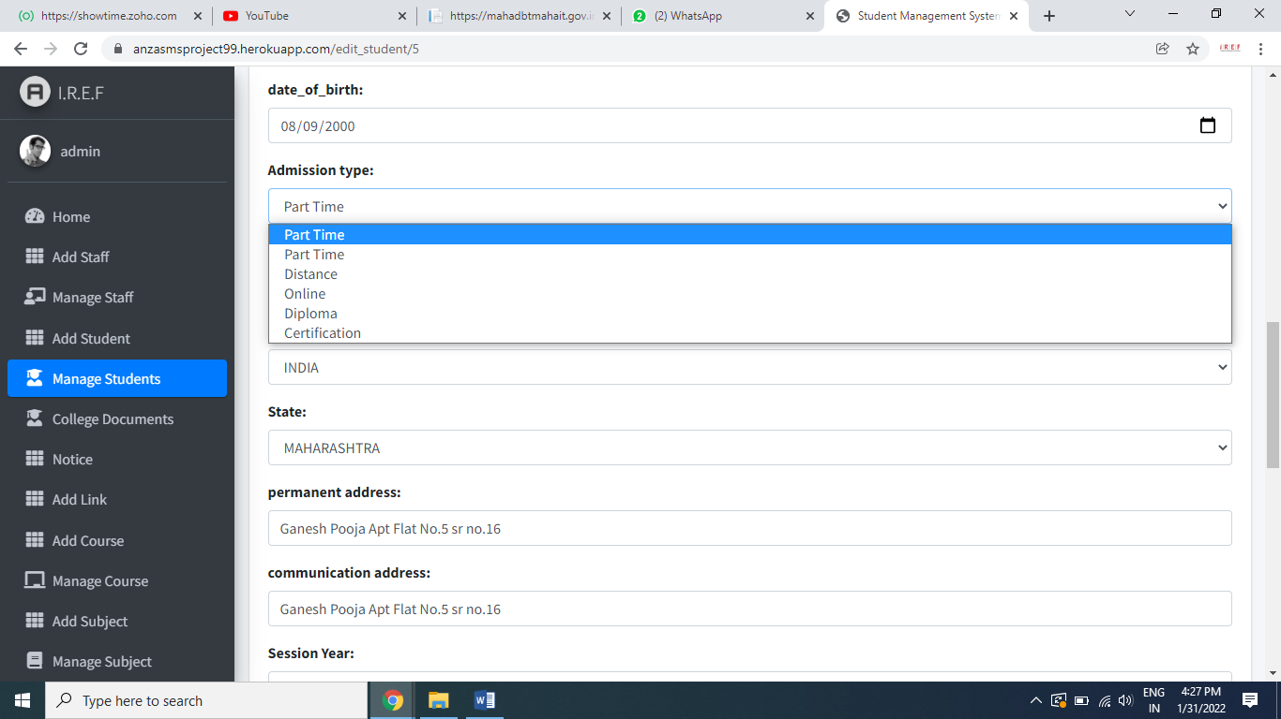

7. Full time is not there is admission type instead of that there are 2 part time option. - **(Done)**

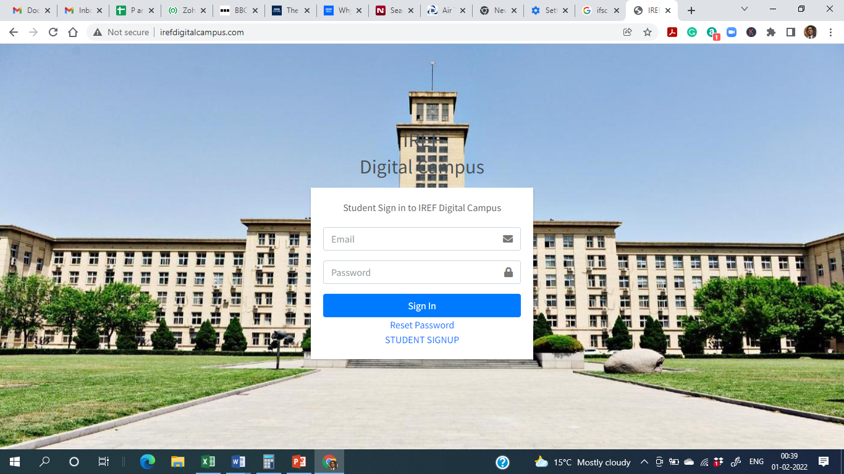

IREF Logo Required in top left

IREF Digital Campus on top not required - **(Done)**

In sign up box –Sign in to IREF Digital Campus Reuired ( remove students )

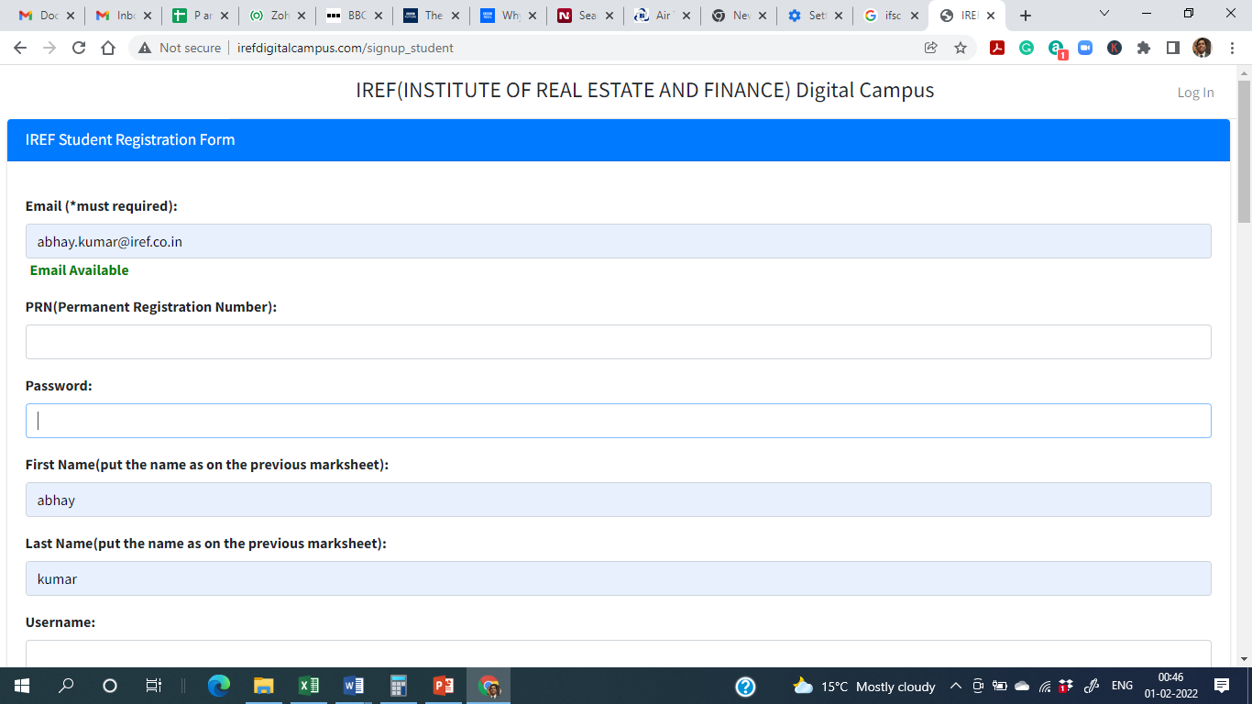

Password (Must required ) – **(Done)**

PRN is not mandatory its for collage use not for students ..we can remove form filling- **(I have make it optional now for student form)**

Admission type is also non mandatory - **(I have make it optional now for student form)**

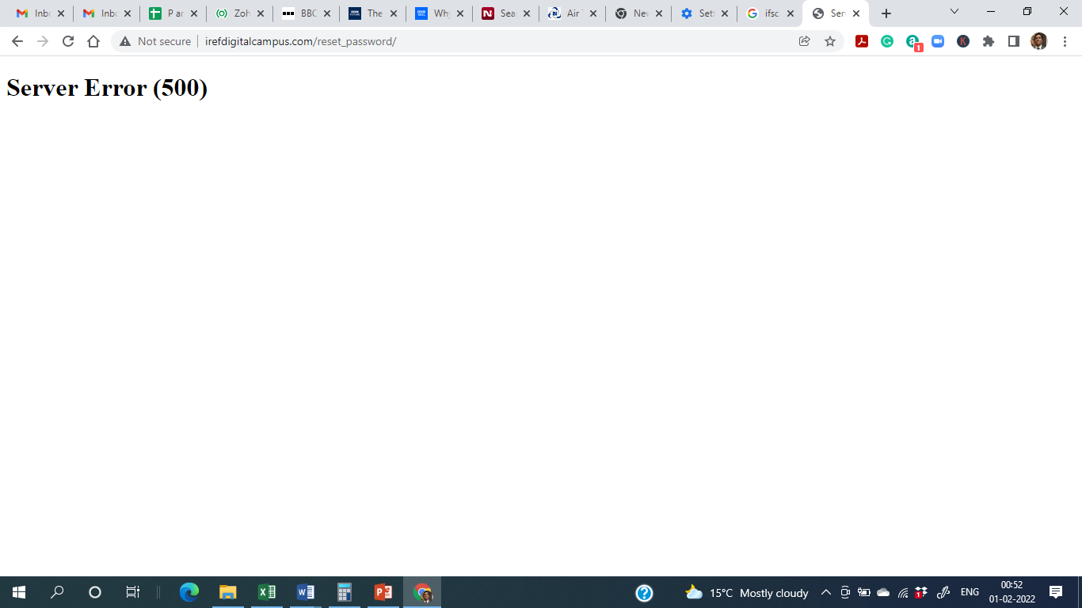

Reset password mail is not working – **(Some live server issues there, Works perfectly fine in local server) –**

**IREF Sendgrid Email -** [**info@iref.co.in**](mailto:info@iref.co.in)

**IREF Sendgrid Account Password - Irefmail123456789#**

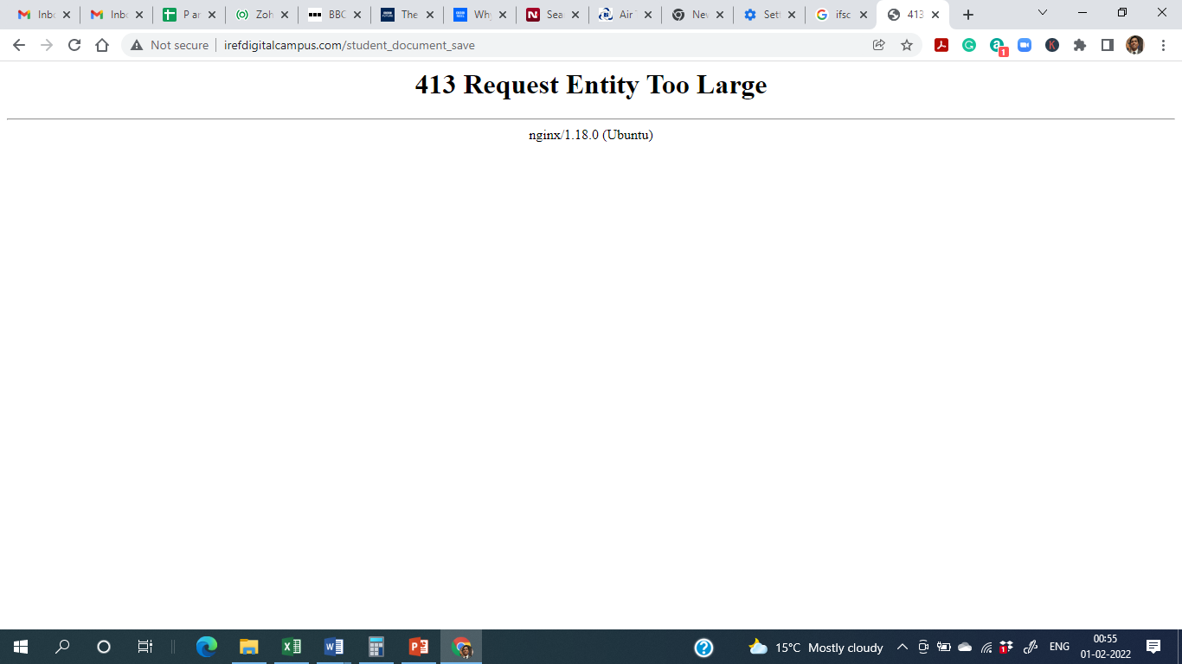

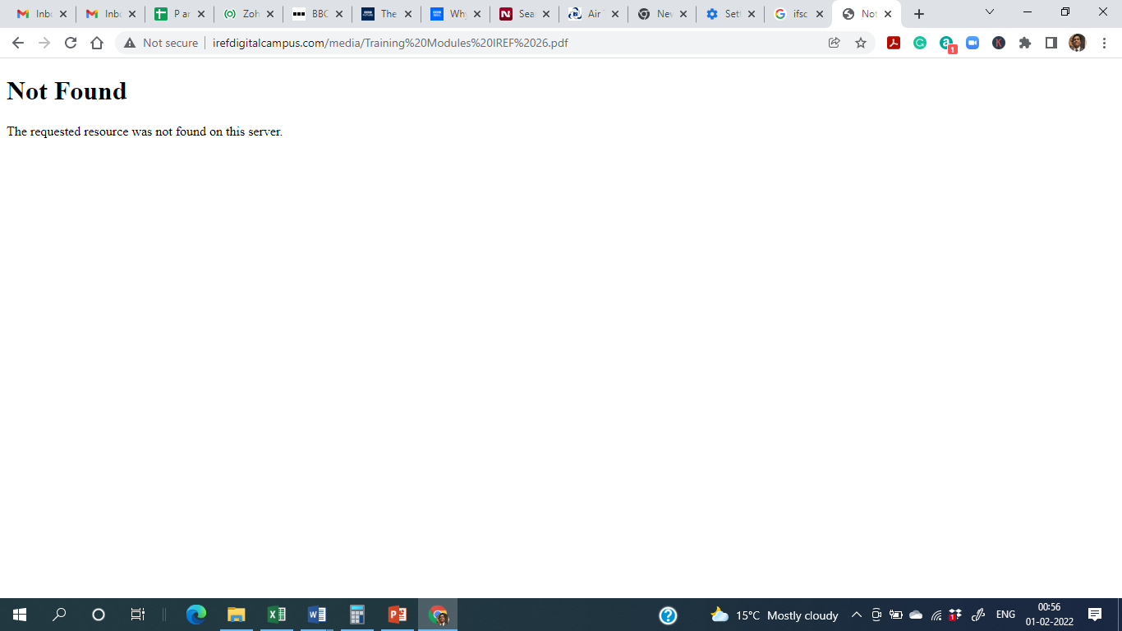

Not able to view file

Down load file not able to view

Admin – **(There is some live server issues ,works perfectly fine in local server)**

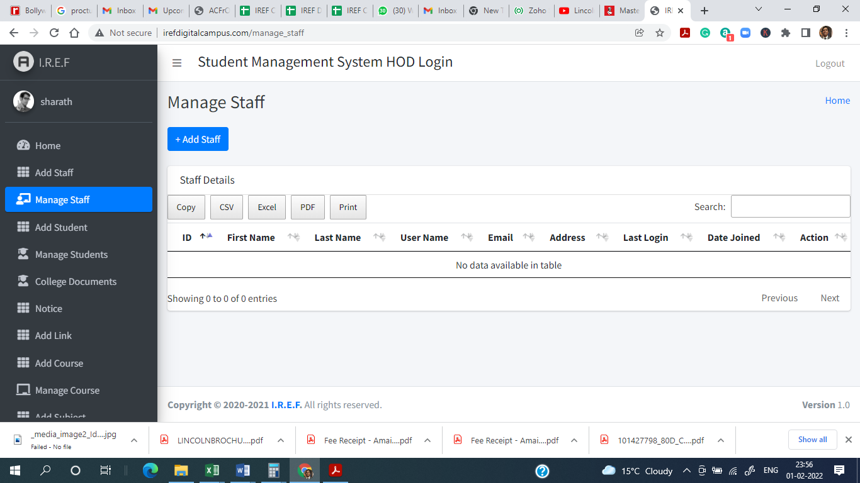

For any delete button put a ask button to reconfirm the delete – **(Done)**

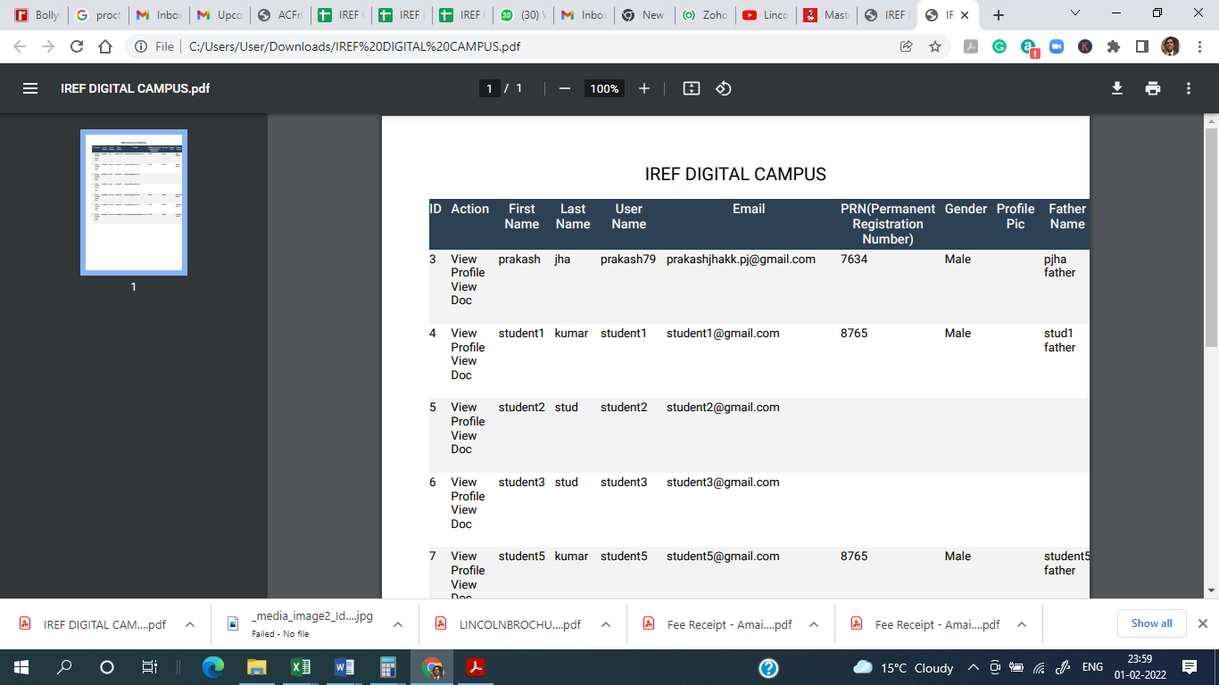

Pdf down layout not coming properly

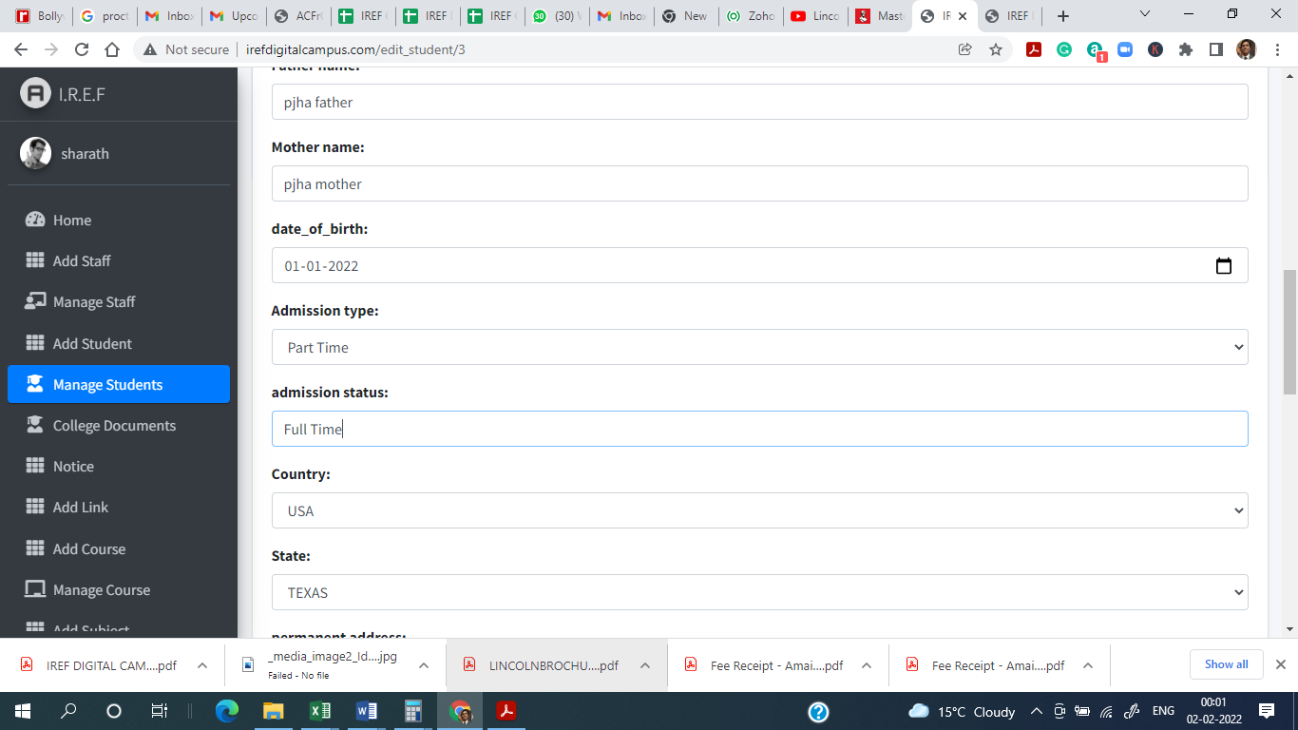

Admission status- drop down - **(DONE)**

Provisional

Confirmed

Others

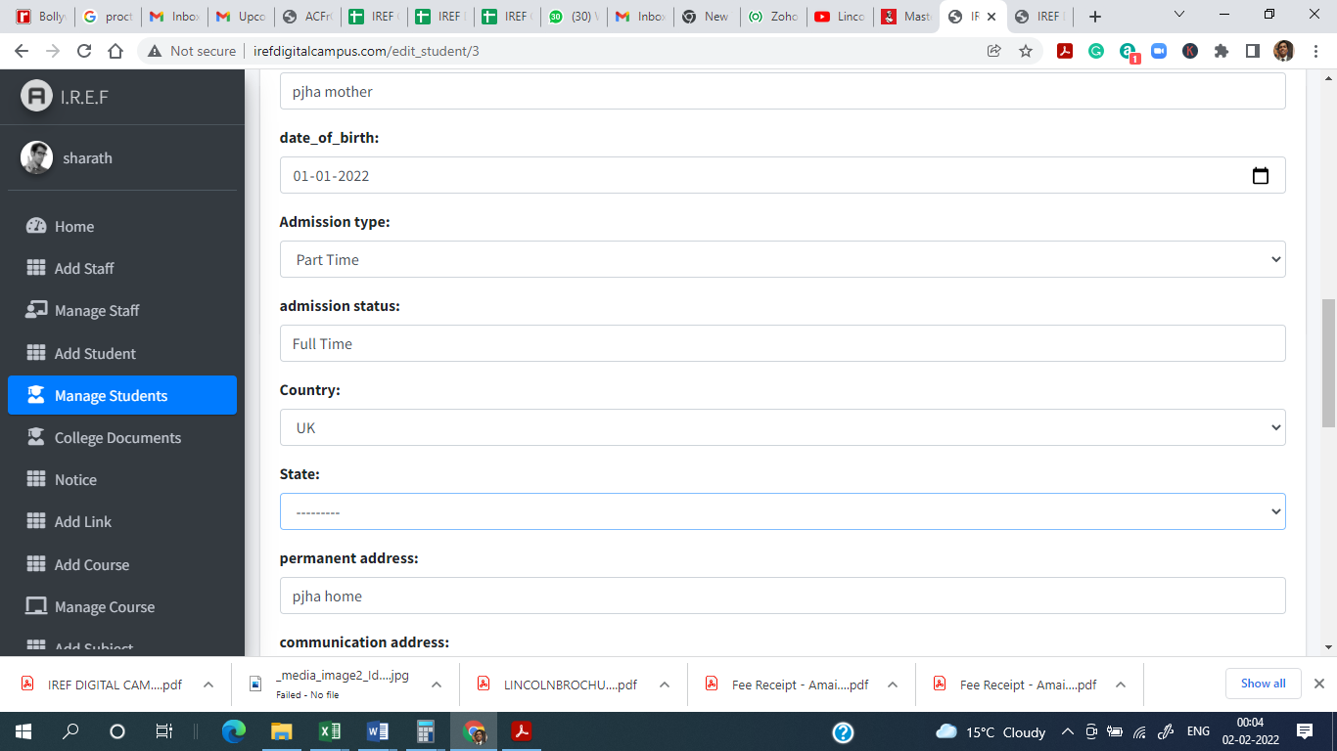

Country and state data entry not available from front end ? How to add data – **(We will look into it)**

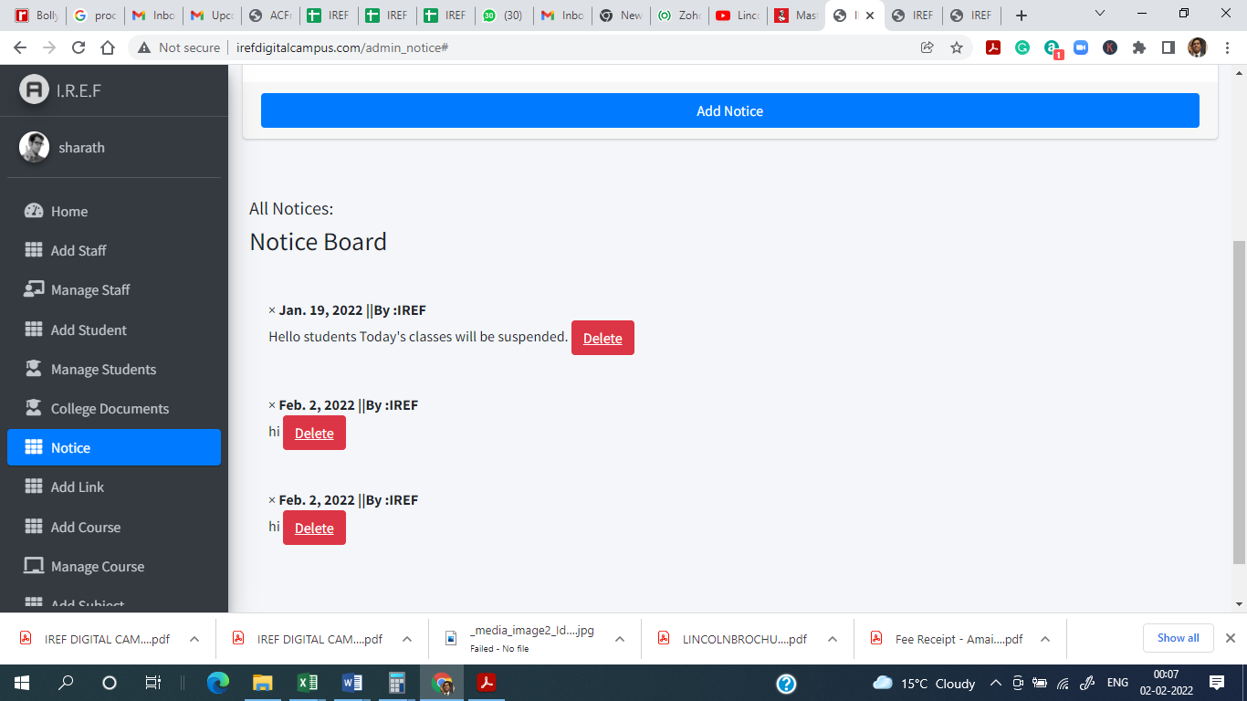

Latest date should come first not the old date (IMP) – (**We will look into it**)

Suggestion

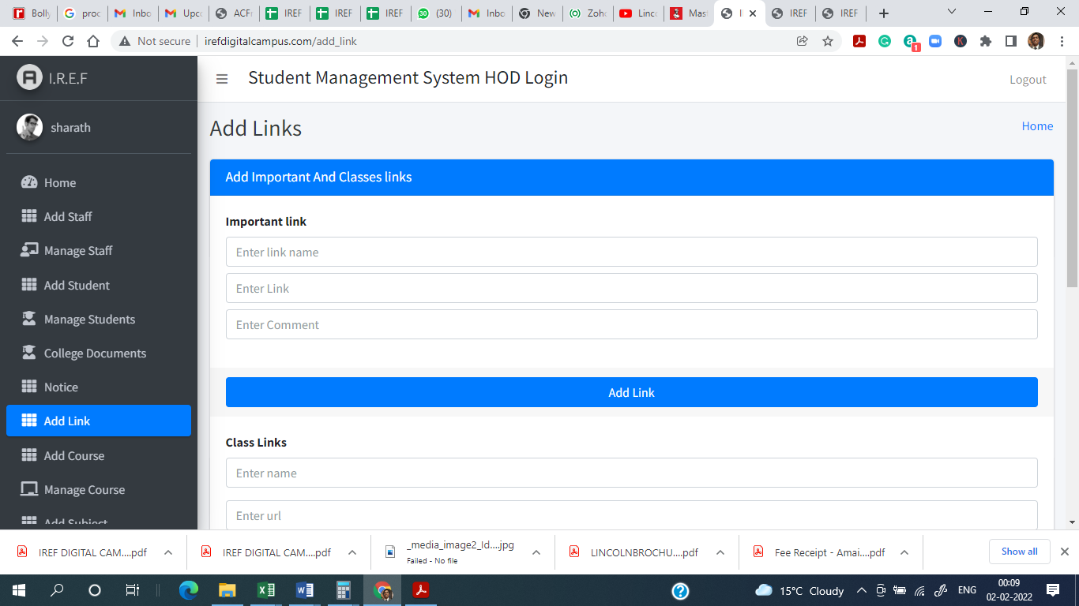

Add one more section payment link as important link and class link **– (Okay fine, After completed all other bugs and fixes we will look into it)**